Name: | ___________________________________________________ |  |  |  | Date: ___________
 | Subject - Year 9 Mathematics  Investigation 2, 2013  Topic – Perimeter & Area  Take home component
Date out: |  | Week ____ Date _____________ | Date Due: | Week ____ Date _____________
Investigation weighting: |  | 6% of the year | Take-home component | 5 Marks
AIM: In this assessment, you will be investigating area and perimeter for simple and compound shapes.
There are two parts to this assessment:
Item | Purpose | Marks available
Take-Home | To expand your knowledge and skill with Perimeter and Area. | 5 Marks
In-Class | To test your knowledge and skill with Perimeter and Area. | 42 Marks

This Take-Home part is to be completed at home and you have one week to complete it. You will not be permitted to do this part in class. If you need help there are after-school maths classes where you can obtain help.

You will be permitted to use your Take-Home part in the In-Class Verification.

Up to five marks will be awarded for completion of this part of the Investigation

SECTION A: PERIMETER

VOCABULARY
Perimeter
The distance around any two-dimensional shape, such as a rectangle or a circle.

Circumference
The distance around a circle.

Radius
The distance from the centre of a circle to the perimeter

Diameter
The width of a circle, measured through its centre.

PI or
A number used in calculations involving circles. It is the number of times the radius goes round the perimeter of a circle.

UNITS
Perimeter, circumference, radius and diameter are all measured in units of length e.g.
mm, cm, m, km etc.

1. | Perimeter of a circle
The length of the perimeter of a circle is equal to the diameter of the circle multiplied by PI ().

Example
A circle has a diameter of 12m.

The length of the perimeter is

- Calculate the length of the perimeter of a circle with a radius of 6m

But what do we do for part circles?

2. | Perimeter of a semi-circle  The perimeter of a semi-circle consists of the arc (curved part) and the diameter (the straight part)  Calculate the length of the arc using  So the total perimeter is  - Calculate the perimeter of a semi-circle having a radius of 4 cm
3 | Perimeter of a quarter circle  The perimeter of a quarter circle again consists of the arc (curved part) and two straight sections of length equal to the radius. The two radii combined are equivalent to the diameter of the circle.  This time calculate the length of the arc using  So the total perimeter is  - Calculate the perimeter of a quarter circle with a diameter of 12 cm  Arc length  Total length of straight sections  Perimeter of the quarter circle
4 | Perimeter of a part circle  Give some thought as to how you would calculate the perimeter of a part circle.  - Calculate the perimeter of a 30 degree section out of a circle of radius 5m.  Arc length =  Total length of straight sections =  Perimeter of the quarter circle =
5 | Perimeter of a scalene triangle  A scalene triangle has no equal sides i.e. all three sides have different lengths.  The Perimeter of a scalene triangle is $a+b+c$  Where $a, b \& c$ are the lengths of the three sides.  - Calculate the size of the perimeter  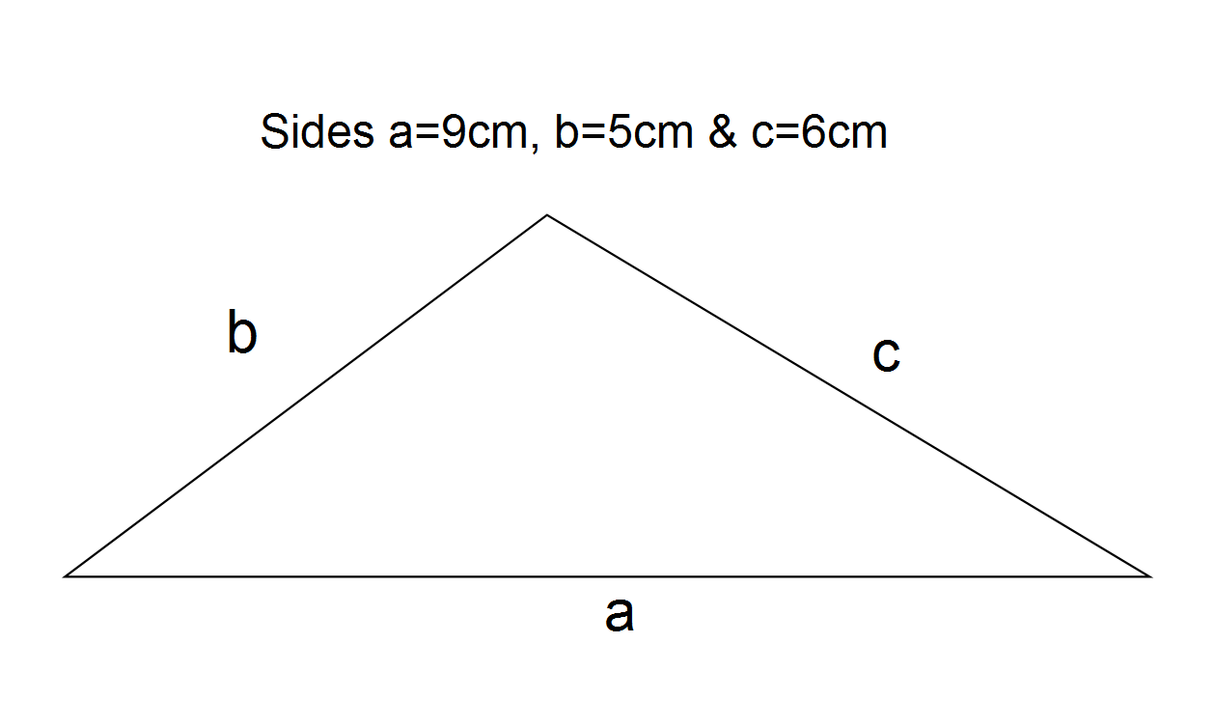
6. | Perimeter of an equilateral triangle  - Describe how would you calculate the perimeter of an equilateral triangle with sides of 5 cm?  - Now do the calculation:

SECTION B: AREA

UNITS
Area is measured in square units e.g. square metres (), square centimetres (), square millimetres () etc.
7. | Area of a circle  The area of a circle is PI multiplied by the radius squared.  In the example r is the radius and so the area is (we normally do not write the )  Example  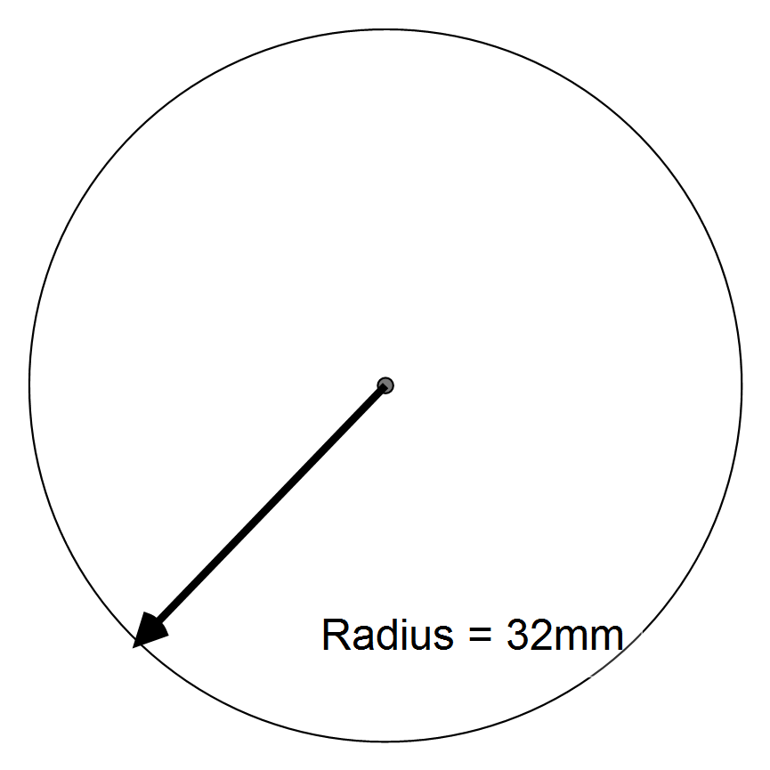  $A=πr^{2}$  $= π × {32}^{2}$  $=3216.99 {mm}^{2}$

8. | Area of a semi-circle  The area of a semi-circle is merely half of the area of a circle with the same radius or diameter  - Calculate the area of a semi-circle having a radius of 12m
9. | Area of a quarter circle  Similarly, the area of a quarter circle is quarter of the area of a circle with the same radius or diameter  - Calculate the area of a quarter taken from a circle of diameter 30cm
10. | Area of part of a circle  - Describe how would you calculate the area of a 30 degree piece of a pie of diameter 20cm?  - Now do the calculation:

11. | Area of a triangle  The area of a triangle is equal to the length of the base multiplied by the perpendicular height and divided by 2. In a right-angled triangle multiply the two shortest sides together and then divide by 2.  Examples:
 | Non-right angled triangle  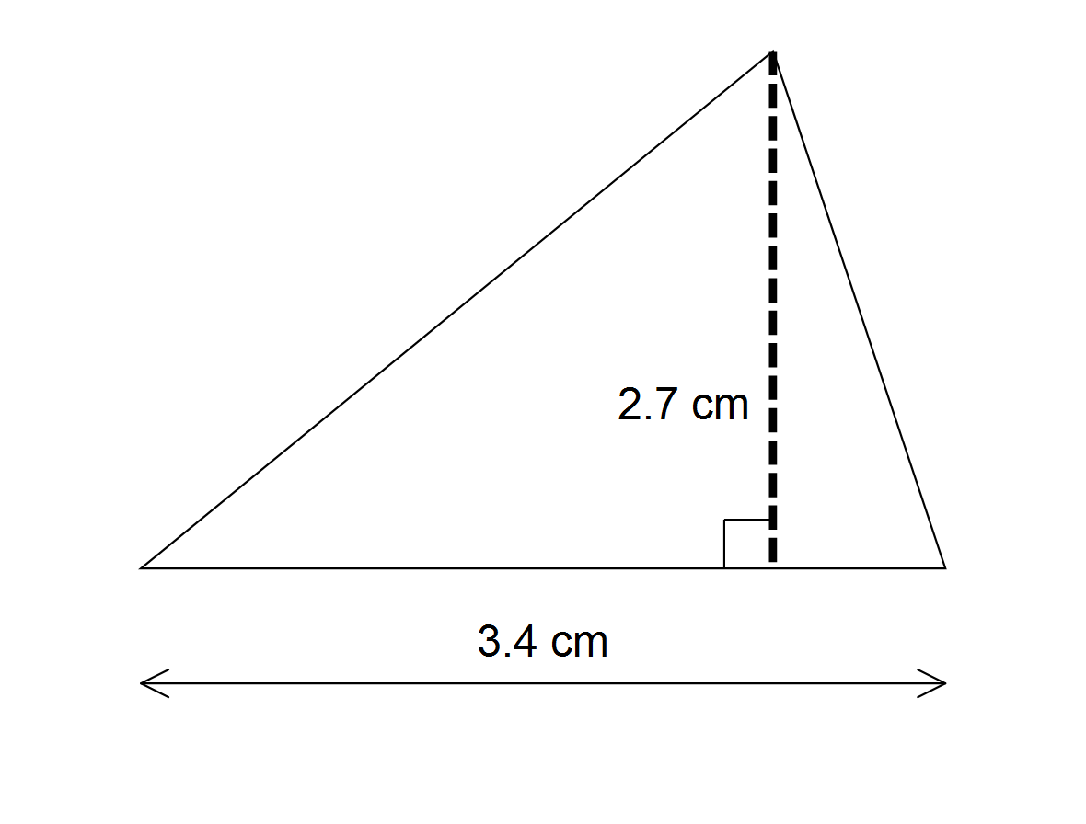  Area = 3.4 x 2.7$÷2$  = 4.59 | Right angled triangle  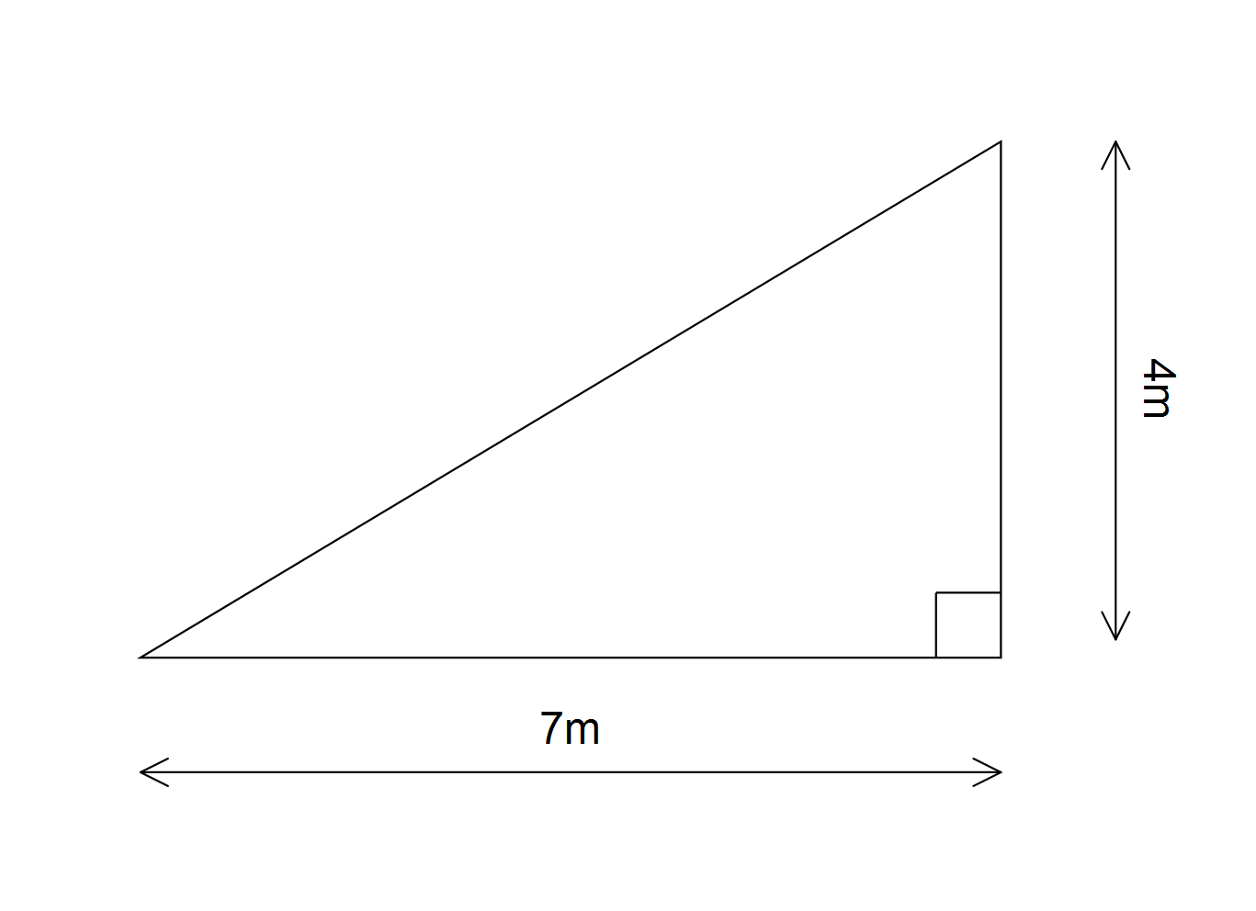  Area = 7 m x 4 m $÷2$  = 14 m²
Now your turn:
Calculate the area of the following:
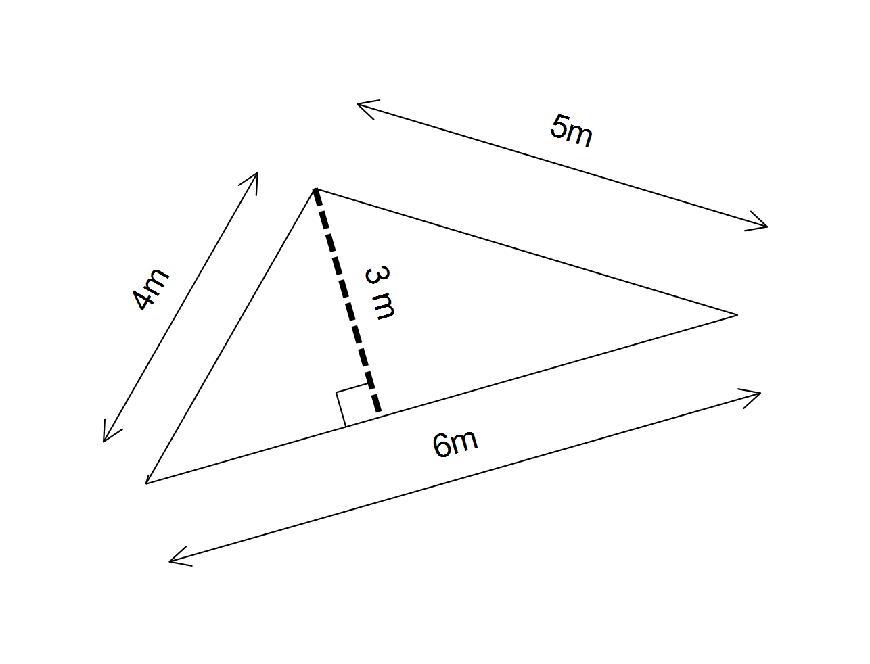

12. | Area of a triangle using Herons Formula
This can be used on any triangle whose sides are all known
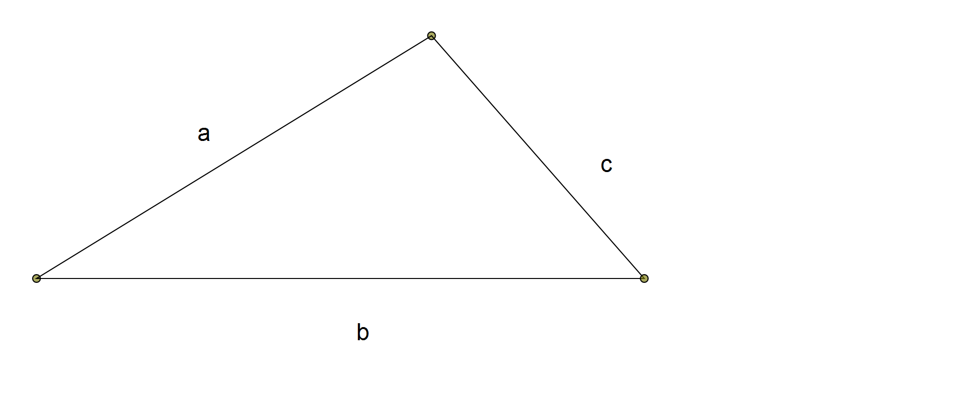

Procedure:
Step 1: Calculate the perimeter () by adding the sides - i.e.

Step 2: Half the value of the perimeter to give the semi-perimeter () - i.e.

Step 3: Subtract each side from the semi-perimeter given by step 2 - i.e. , &

Step 4: Multiply and the three numbers from Step 3 together -

Step 5: The area of the triangle is equal to the square root of the answer from Step 4

Thus the area of a triangle having sides , is given by
Area = where

Example

Step 1: Perimeter
Step 2:Semi-perimeter
Step 3: Subtract each side from the semi-perimeter given by step 2 -
, and

Step 4:

Step 5: The area of the triangle =

Now you try:

Use Heron's formula to calculate the area of a triangle with sides 4m, 6m & 7m

